**Introduction:**

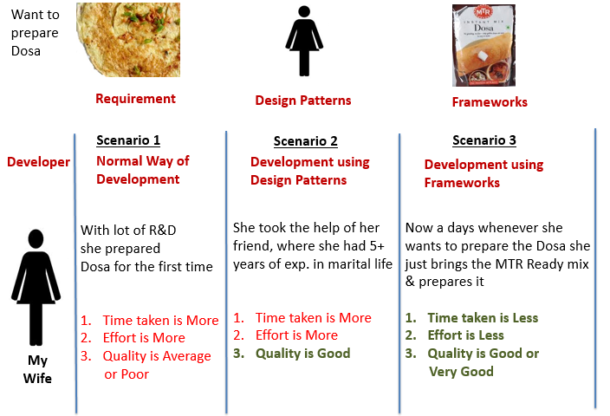

**Frameworks:**

* Framework is a set of JAR files (one or more) which provide specific functionality to applications
* Few examples :

Apache ANT (Build Framework)

JUnit (Unit Testing Framework)

Log4J (logging framework)

Hibernate (ORM Framework / tool)

Struts (Web Application Development Framework)

Springs (Dependency Injection Framework majorly used for Web Application Development)

* Frameworks consist of frozen spots and hot spots.
* Frozen spots define the overall architecture of a software system, i.e. its basic components and the relationships between them. These remain unchanged (frozen).
* Hot spots represent those parts where the programmers using the framework add their own code to add the functionality specific to their own project.

**Advantages of Frameworks:**

* Using code which has already been built, tested, and used by other programmers increases reliability and reduces programming time. This effectively saves lot of coding efforts & in turn reduces project cost
* Frameworks often use best industry practices and design patterns. Hence our application indirectly inherits these features

**Insert Table of Contents when its ready**